Project Design Phase-II

Technology Stack(Architecture&Stack)

|  |  |
| --- | --- |
| Date | 28 October2022 |
| Team ID | PNT2022TMID07573 |
| Project Name | Nutrition Assistant Application |
| Maximum Marks | 4 Marks |

Technical Architecture:

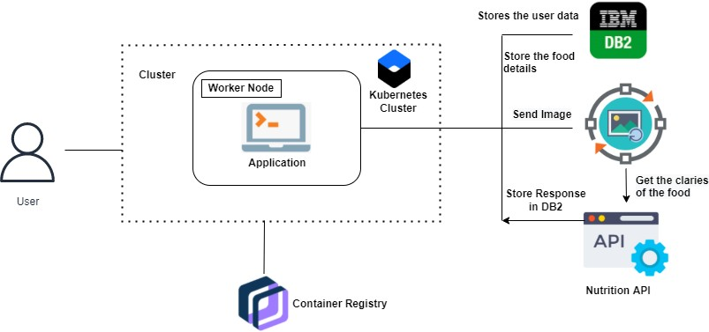

**Table-1: Components & Technologies:**

|  |  |  |  |
| --- | --- | --- | --- |
| **S.No** | **Component** | **Description** | **Technology** |
| 1. | User Interface | user interacts with application | HTML,CSS,JavaScript,ReactJsetc. |
| 2. | Database | DataType,Configuration setc. | MySQL,javascript,python,flask |
| 3. | Cloud Database | Database Service on Cloud | IBMDB2,IBMCloudantetc. |
| 4. | File Storage | File storage requirements | IBM Block Storage or Other Storage Service or Local File system |
| 5. | External API-1 | To predict the image that user will upload in the  upload image page | Clarifai’s AI-driven Food detection Model  API |
| 6 | External API-2 | Food API’s for to the nutritional value for the identified food | Food API |
| 7 | Infrastructure(Server/Cloud) | Application Deployment on Local System/Cloud  Local Server Configuration: Cloud Server Configuration: | Local,Cloud Foundry,  Kubernetes,Docker.. |

Table-2: Application Characteristics:

|  |  |  |  |
| --- | --- | --- | --- |
| **S.No** | **Characteristics** | **Description** | **Technology** |
| 1. | Open-Source Frame works | open-source frameworks used | Send Grid,Python |
| 2. | Security Implementations | Request authentication using encryption | .Encryptions |
| 3. | Scalable Architecture | The scalability of architecture consists of 3 tiers | WebServer–HTML,CSS,JavaScript Application Server – Python Flask DatabaseServer–IBMCloud |
| 4. | Availability | Availability is increased by loads balancers in cloud VPS | working to reduce the severity and likelihood of problems, closely monitoring applications and infrastructure, keeping technical debt in check, automating recovering mechanisms,and regularly putting those recovery mechanisms to the test. |
| 5. | Performance | The application is expected to handle upto 4000 predictions per second | Optimize image sizes, use a content delivery network,use website caching and adopt cloud based website monitoring |